“Leo Tolstoy”

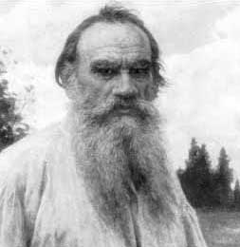

“There can be no doubt that the Prophet Muhammad was one of the greatest reformers who have rendered great services to human society. It is sufficient to say that he guided an entire nation to the light of truth, and made it incline towards tranquility and peace, and preferred a life of asceticism, and prevented bloodshed and human sacrifice; he showed them the way to advancement and civilization. This is a great achievement that can only be made by one who is given strength; such a man is deserving of respect and honor.”

Leo Tolstoy

”LaMartaine”

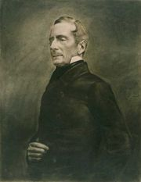
“Who could dare compare any great man in history with Muhammad? The most famous men created arms, laws, and empires only. They founded, if anything at all, no more than material powers which often crumbled away before their eyes. This man moved not only armies, legislations, empires, peoples, dynasties, but millions of men in one-third of the then inhabited world; and more than that, he moved the altars, the gods, the religions, the ideas, the beliefs and the souls. As regards all standards by which human greatness may be measured, we may well ask, is there any man greater than he?”

Alphonse de Lamartine

The famous thinker

“Gustave Le Bon”

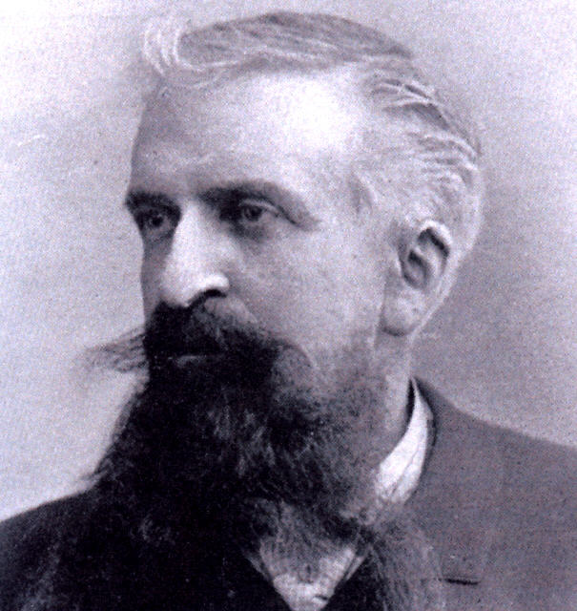
“Muhammad met all the harming and torturing with patience and endurance.”

“Muhammad treated the people of Quraysh, who were his enemies for twenty years, with tolerance and kindness. He saved them from the might of his companions with great difficulty.

He settled with purifying the Ka’aba from the 360 idols which he ordered to be thrown and destroyed. Then he declared the Ka’aba an lamic shrine which it was from that time onwards.”

“If men are measured by their great achievements, Muhammad would be the greatest man ever in history.”

Gustave Le Bon

The distinguished English scientist

“Sir Thomas Arnold”

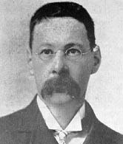
“Muhammad took leadership for an interval that could have been available for any other independent leader. Only the difference was that the religious tie between the Muslims was like a blood-tie. At that same time he established a political system that was entirely distinguished from any other.”

“The purpose from imposing head-taxes on the Christians was not, as many researchers thought, to impose any form of punishment for not accepting Islam. They used to pay these taxes along with all the other non-Muslims whose faiths did not permit them to join the army. So it was in exchange for the protection the Muslim swords provided them with.”

Arnold Walker Thomas

“Mahatma Gandhi”

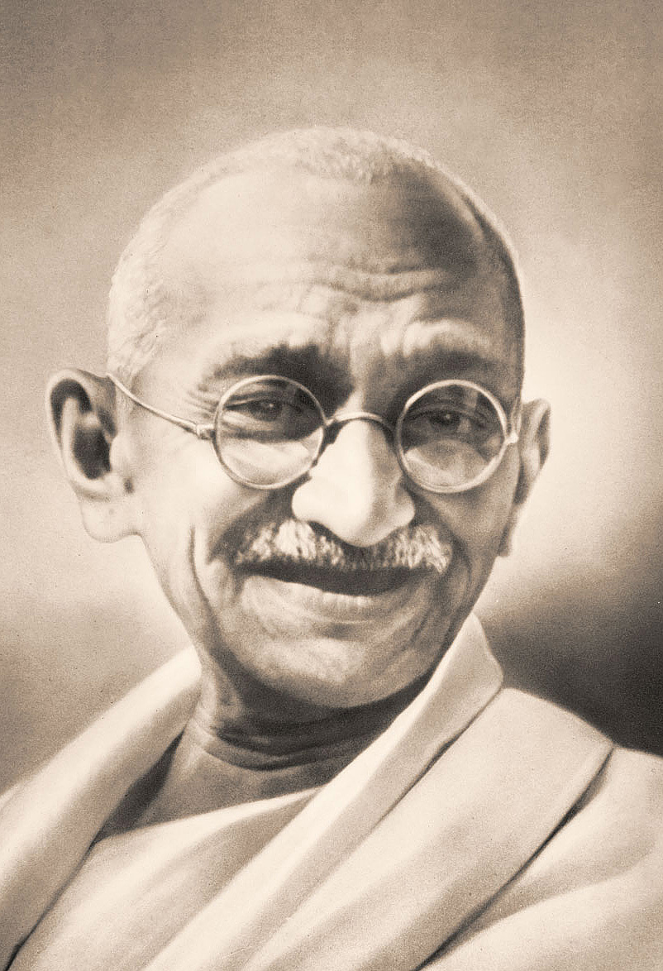

“I became more than ever convinced that it was not the sword that won a place for Islam in those days in the scheme of life. It was the rigid simplicity, the utter self-effacement of the Prophet, the scrupulous regard for pledges, his intense devotion to his friends and followers, his intrepidity, his fearlessness, his absolute trust in God and in his own mission. These and not the sword carried everything before them and surmounted every obstacle. When I closed the second volume (of the Prophet's biography), I was sorry there was not more for me to read of that great life.”

Gandhi

Sir “Thomas Carlyle”

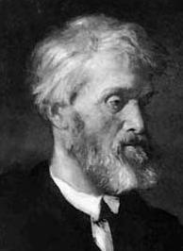
“Fanatics and atheists claim that Mahomet was after none but personal fame, luxury and power. By God, the heart of this poor, hard-toiling man who had radiant eyes and a great spirit was so full of mercy, goodness, tenderness and wisdom. His ideas were so far from worldly greed and his intentions were so far from seeking any power or fame.”

“I see in Mahomet all the signs of nobility and I see in his mind all the signs of wisdom. I see in him a man with a strong heart and true genius. If he wanted, he could be an articulate poet, a heroic knight, a fearless king or any other type of hero he wanted to be.”

Thomas Carlyle

George “Bernard Shaw

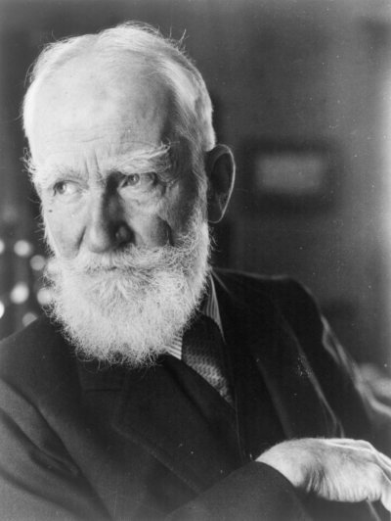

“Muhammad was the spirit of mercy. His influence has survived through all times and ages. None of the people who lived with him have forgotten him, nor will those who have lived after him.”

George Bernard Show

The great American orientalist

“Washington Irving”

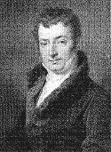

“His military triumphs awakened no pride nor vain glory as they would have done had they been effected by selfish purposes. In the time of his greatest power he maintained the same simplicity of manner and appearance as in the days of his adversity. So far from affecting regal state, he was displeased if, on entering a room, any unusual testimonial of respect was shown to him.”
Washington Irving

“George Sarton”

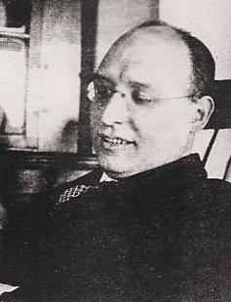

“To sum it up: Muhammad came with a monotheistic religion even before Christianity called for it by more than 9 centuries. Never before has any prophet managed to gather such an amount of victories as Muhammad did.”

George Sarton

The great German novelist

“Wolfgang Goethe”
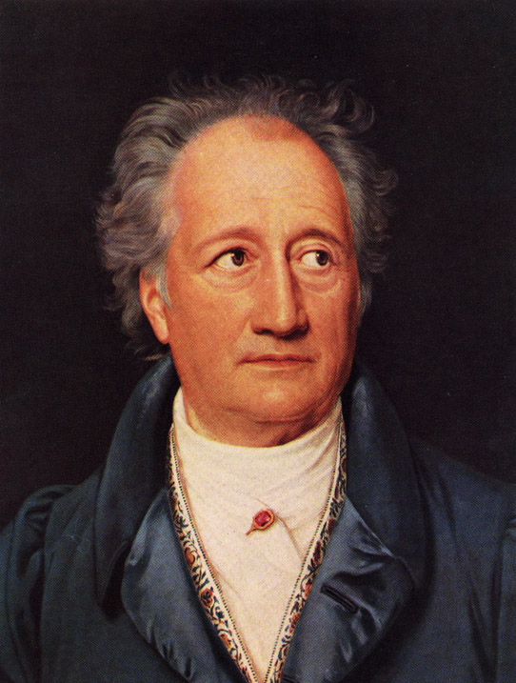

“I have searched throughout the history for a role model to man, and I found none but the prophet Muhammad.”

Johann Wolfgang Goethe

“Will Durant”

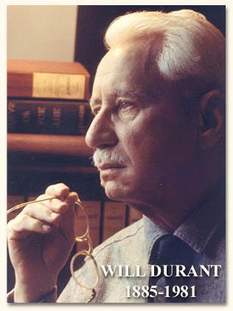

“If we measure greatness by the extent of influence left by great men in the hearts of people we will see that Muhammad was one of the greatest men ever known to history.”

Will Durant

“Fried von Bismarck”



“I can assume that Muhammad is an excellent role model and that there’s no way we can find any similar role model like Muhammad again.

Humanity saw a great model in you once and never again will it ever find anyone like you again.”

Fried von Bismarck

“Michael Hart”

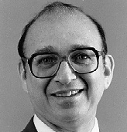

“My choice of Muhammad to lead the list of the world’s most influential persons may surprise some readers and may be questioned by others, but he was the only man in history who was supremely successful on both the secular and religious level.”

Michael Hart

“Fares Khory”

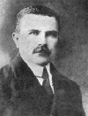

“Muhammad was the greatest of the great men in history. None like him will ever be found again. The religion he came with complemented and completed all the other religions.”

Fares Khory

“Montgomery Watt”

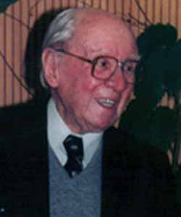
“His readiness to undergo persecution for his beliefs, the high moral character of the men who believed in him and looked up to him as a leader, and the greatness of his ultimate achievement - all argue his fundamental integrity.”

William Montgomery Watt

“Bosworth Smith”

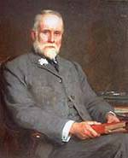
“He was Caesar and Pope in one; but he was Pope without Pope's pretensions, Caesar without the legions of Caesar: without a standing army, without a bodyguard, without a palace, without a fixed revenue; if ever any man had the right to say that he ruled by the right divine, it was Mohammed, for he had all the power without its instruments and without its supports.”

Bosworth Smith

The Prophet in the eyes of fair western eyes, translated by Al-Hussainy Al-Hussainy Ma’ady.
Alphonse de LaMartaine “Historie de la Turquie”, Paris, 1854, page 276-277.
French orientalist born in 1841. One of his famous books, “The Civilization of the Arabs”, is considered an important reference used in the modern age in Europe. This book does great justice to the Islamic civilization. Le Bon died in 1921.
Le Bon: The Civilization of the Arabs, page 104-105.
Ibid. page 108.
Ibid. page 116.
Famous English historian and one of the greatest orientlists. He was born in 1864 and he was the dean of the Oriental Languages School in London, in 1904. One of his most famous writings is: The Preaching of Islam. He died in 1930.
The Preaching of Islam, A History of the Propagation of the Muslim Faith, Sir Thomas W. Arnold, Westminster A. Constable & Co., London, 1896, p. 52.
Ibid. page 79.
An interview with Gandhi by the “Young India” newspaper. Islam-On-Line.
Thomas Carlyle, Heroes, page 68-69.
Ibid. page 82.
George Bernard Shaw, The Greatness of Islam, Volume 1.
Washington Irving, Life of Muhammad, page 72.
One of the greatest historians. Born in Belgium in 1884. He was a lecturer in world history at the University of Boston in 1916, then in Harvard (1917-1949). He died in 1956.
Sarton, The Incubation of Western culture in the Middle East, translated by Dr. Omar Faroukh, page 28-30.
Noten und Abhandlungen zum Weststlichen Dvan, by Goethe.
Will Durant, The Story of Civilization, vol. 13, page 59.
German journalist. Head of the German board for journalism.
A report published by the international news agencies following the publishing of the offensive Danish cartoons.
Michael Hart, The 100, page 29.
Fares Khory, Islam & Modern Science, page 62.
Montgomery Watt, Muhammad at Mecca, pages 52 and 512.
Bosworth Smith, Muhammad and Muhammadism, page 92.

